Naloga 4.1

a.)

i)

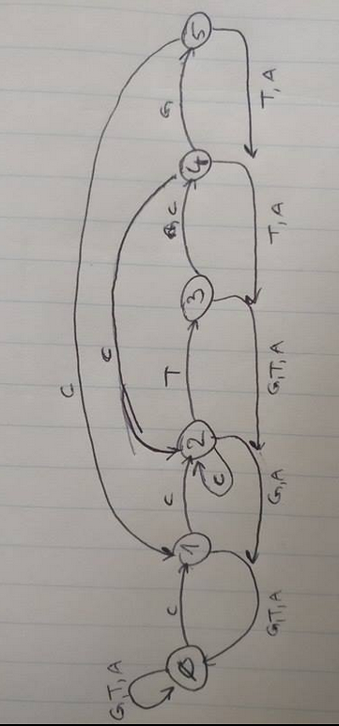

|  |  |  |  |  |
| --- | --- | --- | --- | --- |
| STATE | C | G | T | A |
| 0 | 1 | 0 | 0 | 0 |
| 1 | 2 | 0 | 0 | 0 |
| 2 | 2 | 0 | 3 | 0 |
| 3 | 4 | 0 | 0 | 0 |
| 4 | 2 | 5 | 0 | 0 |
| 5 | 1 | 0 | 0 | 0 |

ii)



iii)

v primeru da najdemo niz se avtomat premakne če je C gremo v 2. Stanje če je pa T ali A pa v 0 stanje.

b.)

